**Unit-VI**

**Equipment Protection**

**Equipment protection:** Main considerations in equipment protection CTs and PTs and their applications in protection in protection schemes.

**Feeder protection:** Transmission line, protection-bus bar protection.

**Generator protection:** Protection for stator faults, rotor faults and protection for abnormal conditions.

**Transformer protection:** Differential protection schemes-Buchholz relay.

**Main considerations in equipment protection**

## Generator Protection Systems-Understanding Common Faults/Failure Conditions

### Generator Protection

When generator control systems are designed, generator protection components are often included in the same cabinet for small to medium facility operations. The generator protection devices and wiring are separate from the control circuit devices and wiring. However, they can interface with the controls system for generator shutdown and alarms/monitoring capabilities.  
**Generator protection can be divided into the below categories:**

* Internal Faults - Phase and/or ground faults in the stator and/or the field winding (rotor).
* Abnormal Operating Conditions - Issues such as: loss of field, overload, over voltage, under/over frequency, loss of synchronization, etc.

The generator is protected from internal faults within the rotor and stator by grounding methods. There are various methods used in grounding the generator. Grounding methods are proportional to size and complexity of facility (larger and more complex designs require more complex grounding circuit). If a generator does not have the appropriate grounding, the rotor and or stator can be damaged beyond repair during a ground fault event.

Protecting your generator from abnormal operating conditions is determined by the system. An emergency power system that only supplies power to lighting and emergency circuits would not need synchronization protection. This article provides information on field excitation, frequency, reverse power, circuit breaker pole flash over, and loss of synchronization failures.

### Circuit Breaker Failures

Circuit breakers defend the generator rotor and stator against failure generated by a component(s) on the load side of the circuit. A line or supply circuit breaker supplies voltage to system breakers. Systems that require un-interruptible power can have redundant or backup capabilities to rapidly bypass the failed circuit breaker. This function can be automatic, manual or a combination of both depending on the failure.

**Circuit breakers fail in two ways:**

* Failed Open - Circuit breaker will not stay in closed condition after circuit repairs. Tripped breaker results in open circuit.
* Failed Closed - Contacts are welded together. The breaker conducts current flow in open, closed and tripped positions. This can cause a circuit to be inadvertently energized.

Breaker flash over also called arc flash is light and heat produced as part of the arc fault. Considered to be a type of electrical explosion. The discharge of the explosion results from a low-impedance connection through air to ground or another voltage phase. An arc blast is the supersonic shockwave produced when the uncontrolled arc vaporizes metal contacts. Flash over can occur during synchronization across breaker terminals while the breaker is open because of internal or external contamination, low dielectric pressure and humidity. Protection schemes are designed to accommodate the facility needs.

### Excitation Failure

The generator consists of a rotor spinning in a magnetic field. Generators that use field coils require current flow to produce the magnetic field. The process of generating the magnetic field by use of an electric current is called excitation.

**Loss of field can occur because:**

* Tripping field breaker
* Open or short in field circuit. Can cause flash over of slip rings.
* Loss of supply to excitation circuit.

With generators operating in parallel, the generator with loss of field over speeds and operates as induction generator receiving excitation from system. Overheating of generator components are common problems. Loss of field protection circuits are designed to prevent unsafe and damaging operation of the generator when the field is lost.

When a generator receives more excitation voltage than required, the effect is counterbalanced by flux moving in the opposite direction added by AC supply and works on leading power factor as a capacitive load. If the excitation field is not correct, the generator will act as an inductive or capacitive load to the system. Advanced power systems will cycle generators that develop excitation failures off-line for troubleshooting.

### Frequency and Power

The number of magnetic polls and the generator engine rpm are included in the calculation to figure the frequency of a generator. The equation is RPM x Poles /120. A generator with 4 poles running at 1800 RPM will generate 60 Hz.

If engine speed raises beyond governed set point or lowers because of mechanical or generator end issues the frequency will proportionally follow the engine. Increase in speed will command higher frequency and decrease will lower the frequency. Advanced systems can secure the affected generator and parallel a standby generator.

Generators exhibiting frequencies abnormalities must be repaired prior to assuming the load.  
When generators are operating in parallel and one generator fails, it satisfies the criteria for a reverse power condition. The failed generator can act as a motor and draw current from the other generators operating on the grid. Power is lost from the grid from the lack of supply from the failed generator. In addition, the failed generator uses power from the grid to operate as a motor. More advanced systems have automatic transfer and paralleling systems that employ reverse power relays.

Synchronization is when more than one generator is used to supply power to the grid in parallel operation. When the generators are operating in parallel, the speed and frequency of the generators are matched proportional rising grid capability. A severe fault may cause loss of synchronism. This can take more than one generator out of service and cause partial or complete loss of power. Circuits have been developed to remove a generator out of service with zero voltage reading before loss of synchronization occurs.

**Generator Protection**

A **generator** is subjected to electrical stresses imposed on the insulation of the machine, mechanical forces acting on the various parts of the machine, and temperature rise. These are the main factors which make protection necessary for the generator or alternator. Even when properly used, a machine in its perfect running condition does not only maintain its specified rated performance for many years, but it does also repeatedly withstand certain excess of overload.

Preventive measures must be taken against overloads and abnormal conditions of the machine so that it can serve safely. Even ensuring an efficient design, construction, operation, and preventive means of protection – the risk of a fault cannot be completely eliminated from any machine. The devices used in **generator protection**, ensure that when a fault arises, it is eliminated as quickly as possible.

An electrical generator can be subjected to either an internal fault or external fault or both. The generators are normally connected to an electrical power system, hence any fault occurred in the power system should also be cleared from the generator as soon as possible otherwise it may create permanent damage in the generator. The number and variety of faults occur in a generator are huge. That is why generator or alternator is protected with several protective schemes. Generator protection is of both discriminative and non-discriminative type. Great care is to be taken in coordinating the systems used and the settings adopted to ensure that a sensitive, selective and discriminative **generator protection scheme** is achieved.

## Types of Generator Protection

The various forms of protection applied to the generator can be categorized into two manners,

1. Protective relays to detect faults occurring outside the generator.
2. Protective relays to detect faults occurring inside the generator.

Other than protective relays, associated directly with the generator and its associated transformer, there are lightning arrestors, over speed safe guards, oil flow devises and temperature measuring devises for shaft bearing, stator winding, transformer winding and transformer oil etc. Some of these protective arrangement are of non-trip type i.e. they only generate alarm during abnormalities.

But the other protective schemes ultimately operate master tripping relay of the generator. This should be noted that no protective relay can prevent fault, it only indicates and minimizes the duration of the fault to prevent high temperature rise in the generator otherwise there may be permanent damage in it. It is desirable to avoid any undue tresses in the generator, and for that it is usual practice to install surge capacitor or surge diverter or both to reduce the effects of lightning and other voltage surges on the machine. The protection schemes usually applied to the generator are discussed here below in brief.

**Protection against Insulation Failure**

The main protection provided in the stator winding against phase to phase or phase to earth fault, is longitudinal differential protection of generator. Second most important protection scheme for stator winding is inter turn fault protection. This type of protection was considered unnecessary in previous days because breakdown of insulation between points in the same phase winding, contained in the same slot, and between which a potential difference exists, very rapidly changes into an earth fault, and then it is detected by either the stator differential protection or the stator earth fault protection. A generator is designed to produce relatively high voltage in comparison to its output and which therefore contains a large number of conductors per slot. With increasing size and voltage of the generator, this form of protection is becoming essential for all large generating units.

### Stator Earth Fault Protection

When the stator neutral is earthed through a resistor, a current transformer is mounted in the neutral to earth connection. Inverse Time Relay is used across the CT secondary when the generator is connected directly to the bus bar. In case of generator feeds power via a delta star transformer, an Instantaneous Relay is used for the same purpose. In the former case, the earth faults relay is required to be graded with other fault relays in the system. This is the reason why Inverse Time Relay is used in this case. But in the latter case, the earth fault loop is restricted to the stator winding and primary winding of the transformer, hence, there is no need of grading or discrimination with other earth fault relays in the system. That is why Instantaneous Relay is preferable in the case.

### Rotor Earth Fault Protection

A single earth fault does not create any major problem in the generator but if the second earth fault is occurred, however, part of the field winding will become short-circuited and resulting and unbalanced magnetic field in the system and consequently there may be major mechanical damage to the bearings of the generator. There are three methods available to detect the types of fault in the rotor. The methods are

1. Potentiometer method
2. AC injection method
3. DC injection method

### Unbalanced Stator Loading Protection

Unbalancing in loading produces negative sequence currents in the stator circuit. This negative sequence current produces a reaction field rotating at twice of synchronous speed with respect to the rotor and hence induce double frequency current in the rotor. This current is quite large and causes overheating in the rotor circuit, especially in the alternator. If any unbalancing occurred due to fault in the stator winding itself, that would be cleared instantaneously by the differential protection provided in the generator. If the unbalancing is occurred due to any external fault or unbalanced loading in the system, it may remain undetected or may persist for a significant period of time depending on the protection coordination of the system. These faults then be cleared by installing a negative phase sequence relay with the characteristics to match the withstand curve of the machine.

### Protection against Stator Overheating

Overloading can causes overheating in the stator winding of the generator. Not only overloading, failure of cooling systems and insulation failure of stator laminations also cause overheating of the stator winding. The overheating is detected by embedded temperature detectors at various points in the stator winding. The temperature detector coils are normally [resistance](https://www.electrical4u.com/what-is-electrical-resistance/) elements which form one arm of the [Wheatstone bridge circuit](https://www.electrical4u.com/wheatstone-bridge-circuit-theory-and-principle/). In the case of smaller generator normally below 30 MW, the generators are not equipped with embedded temperature coil but are usually fitted with thermal relay and they are arranged to measure the current flowing in the stator winding. This arrangement only detects overheating caused by overloading and does not provide any protection against overheating due to failure of cooling systems or short circuited stator laminations. Although [over current relays](https://www.electrical4u.com/over-current-relay-working-principle-types/), negative phase sequence relays, and devises for monitoring constant flow are also used to provide a certain degree of [thermal overload protection](https://www.electrical4u.com/motor-thermal-overload-protection/).

### Low Vacuum Protection

This protection, usually is in the form of a regulator which compares the vacuum against atmospheric pressure, it is normally fitted to the generator set above 30 MW. The modern practice is for the regulator to unload the set via the secondary governor until normal vacuum conditions are restored. If the vacuum conditions do not improve below 21 inch the stop valves are closed and the main [circuit breaker](https://www.electrical4u.com/electrical-circuit-breaker-operation-and-types-of-circuit-breaker/) is tripped.

### Protection against Lubrication Oil Failure

This protection is not considered essential since the lubrication oil is normally obtained from the same pump as governor oil and a failure of the governor oil will automatically make stop valve to close.

### Protection against Loss of Boiler Firing

Two methods are available for detecting the loss of boiler firing. In the first method, normally opened (NO) contacts are provided with the fan motors which may trip the generator if more than two motors fail. The second methods use a [boiler](https://www.electrical4u.com/steam-boiler-working-principle-and-types-of-boiler/) pressure contacts which unload the generator if boiler pressure falls below approximately 90%.

### Protection against Prime Mover Failure

If the prime mover fails to supply mechanical energy to the generator, the generator will continue to rotate in motoring mode that means it takes electrical energy from the system instead of supplying it to the system. In [steam](https://www.electrical4u.com/steam/) turbine set the steam acts as a coolant maintaining the turbine blades at a constant temperature. Failure of the supply will therefore result in overheating due to friction, with subsequent distortion of turbine blades. The, failure of steam supply can cause severe mechanical damage in addition of imposing a heavy motoring load on the generator. Reverse power relay is used for this purpose. As soon as the generator starts rotating in motoring mode, the reverse power relay will trip the generator set.

### Over Speed Protection

While it is the general practice to provide mechanical over speed devices on both steam and hydro turbine, which operate directly on the steam throttle valve or main step valve, it is not usual to backup this devises by an over speed relay on steam driven sets. It is, however, considered good practice on hydroelectric units, as the response of the governor is comparatively slow and the set is more prone to over-speed. The relay when fitted is usually supplied from the permanent magnet generator used for the control of governor.

### Protection against Rotor Distortion

The cooling rates following shutdown, at the top and bottom of the turbine casing, are different and this uneven temperature distribution tends to cause destruction of the rotor. To minimize the disruption, it is common practice to turn the rotor at low speed during the cooling down period. In the view of the forces involved with large modern rotor, it is now standard practice to fit shaft eccentricity detectors.

### Protection against Difference in Expansion between Rotating and Stationary parts

During the running up period, the rate of heating of the rotor differs from that of the casing, due to the difference in mass. As a result, the rotor expands at a different rate to the casing and it is necessary to overcome this unequal expansion. To this end, proposition is made on the larger machine for independent supplies of steam to be set to certain joints on the casing. It is desirable therefore to provide a means of measuring the axial expansion to assist the operator to feed the steam to the correct points and also to provide indication of any dangerous expansion. The shaft axial expansion detector is basically similar to the equipment described for rotor distortion equipment, except that the detector magnets are fixed to the turbine casing.

### Protection against Vibration

Vibration detectors are usually mounted on the bearing pedestals. The detector consists of a coil mounted on springs between U shaped permanent magnets. The voltage output from the coil, which is proportional to the degree of vibration, is passed from the coil into integrating circuits and then into interval indicating instrument.

### Back up Protection of Generator

Back up protection should always be given in highly rated machine like [synchronous generator](https://www.electrical4u.com/alternator-or-synchronous-generator/) or alternator. If faults occurred had not been cleared by the appropriate protection scheme then back up [protection relays](https://www.electrical4u.com/types-of-electrical-protection-relays-or-protective-relays/) should be operated to clear the fault. Over current relays are generally used for this purpose. Because the synchronous reactance of modern machine is often greater than hundred percent, the sustained fault current fed from the machine into an external fault is invariably below the normal full load current. The normal IDMT relays would not prove satisfactory because their current settings must be close to the full load and their time sitting short if operation is to be obtained, resulting in probable lack of discrimination with other over current relays in the system. Further, the over current relay would most probably operate for loss of field on the machine, disconnecting it prematurely. To overcome this problem is it has become customary to apply an over current relay in combination with under voltage relay, the latter relay controlling the fault settings of the former as shown in the figure.

# Inter Turn Fault Protection of Stator Winding of Generator

Inter turn stator winding fault can easily be detected by stator differential protection or [stator earth fault protection](https://www.electrical4u.com/stator-earth-fault-protection-of-alternator/). Hence, it is not very essential to provide special protection scheme for inter turn faults occurred in stator winding. This type of faults is generated if the insulation between [conductors](https://www.electrical4u.com/electrical-conductor/) (with [different potential](https://www.electrical4u.com/voltage-or-electric-potential-difference/)) in the same slot is punctured. This type of fault rapidly changes to earth fault. The high [voltage](https://www.electrical4u.com/voltage-or-electric-potential-difference/) generator contains a large number of conductors per slot in the stator winding hence, in these cases the additional inter turn fault protection of the stator winding may be essential. Moreover in modern practice, inter turn protection is becoming essential for all large generating units.

Several methods can be adopted for providing inter turn protection to the stator winding of generator. Cross differential methods is most common among them. In this scheme the winding for each phase is divided into two parallel paths.

Each of the paths is fitted with identical [current transformer](https://www.electrical4u.com/current-transformer-ct-class-ratio-error-phase-angle-error-in-current-transformer/). The secondary of these current transformers are connected in cross. The current transformer secondary’s are cross connected because [currents](https://www.electrical4u.com/electric-current-and-theory-of-electricity/) at the primary of both CTs are entering unlike the case of [differential protection of transformer](https://www.electrical4u.com/differential-protection-of-transformer-differential-relays/) where current entering from one side and leaving to other side of the [transformer](https://www.electrical4u.com/what-is-transformer-definition-working-principle-of-transformer/).  
The [differential relay](https://www.electrical4u.com/differential-relay/) along with series stabilizing resistor are connected across the CT secondary loop as shown in the figure. If any inter turn fault occurs in any path of the stator winding, there will be an unbalanced in the CT secondary circuits thereby actuates 87 differential relay. Cross differential protection scheme should be applied in each of the phases individually as shown.

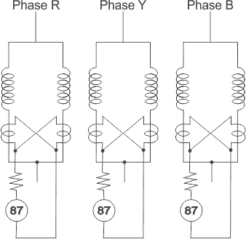

An alternative scheme of inter turn fault protection of stator winding of generator is also used. This scheme provides complete protection against internal faults of all synchronous machines irrespective of the type of the winding employed or the kind of methods for connection. An internal fault in the stator winding generates second harmonic current, included in the field winding and exciter circuits of the generator. This current can be applied to a sensitive polarized relay via a CT and filter circuit.

The scheme operation is controlled by a direction of negative phase sequence relay, in order to prevent operation during external unbalanced faults or asymmetrical load conditions. Should there be any asymmetry external to the generator unit zone, the negative phase sequence relay prevents a complete shutdown, only allowing the main [circuit breaker](https://www.electrical4u.com/electrical-circuit-breaker-operation-and-types-of-circuit-breaker/) to be tripped, to prevent the rotor damage due to the over rating effects of second harmonic currents.

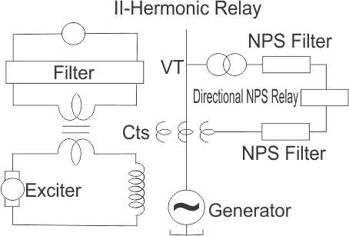

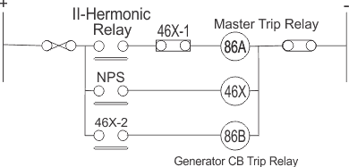

# Stator Earth Fault Protection of Alternator

This is to be noted that, the star point or neutral point of stator winding of an [alternator](https://www.electrical4u.com/alternator-or-synchronous-generator/) is grounded through an impedance to limit the ground fault current. Reduced ground fault current causes less damage to the stator core and winding during ground or earth fault. If the ground impedance is made quite high, the ground fault current may become even less than normal rated current of the generator. If so, the sensitivity of phase relays becomes low, even they may fail to trip during fault. For example, a current lower than rated current makes it difficult to operate [differential relays](https://www.electrical4u.com/differential-relay/) for ground fault. In that case, a sensitive ground/earth fault relay is used in addition to the [differential protection of alternator](https://www.electrical4u.com/differential-protection-of-generator-or-alternator/). What type of relaying arrangement will be engaged in **stator earth fault protection of alternator** depends upon the methods of stator neutral earthing. In the case of [resistance](https://www.electrical4u.com/what-is-electrical-resistance/) neutral earthing the neutral point of stator winding is connected to the ground through a [resistor](https://www.electrical4u.com/types-of-resistor/).

Here, one [current transformer](https://www.electrical4u.com/current-transformer-ct-class-ratio-error-phase-angle-error-in-current-transformer/) is connected across the neutral and earth connection of the alternator. Now one [protective relay](https://www.electrical4u.com/types-of-electrical-protection-relays-or-protective-relays/) is connected across the current transformer secondary. The alternator can feed the power system in two ways, either it is directly connected to the [substation](https://www.electrical4u.com/electrical-power-substation-engineering-and-layout/) bus bar or it is connected to substation via one [star delta transformer](https://www.electrical4u.com/delta-star-transformation-star-delta-transformation/). If the generator is connected directly to the substation bus bars, the relay connected across the CT secondary, would be an inverse time relay because here, relay coordination is required with other fault relays in the system. But when the stator of the alternator is connected to the primary of a star Delta transformer, the fault is restricted in between stator winding and transformer primary winding, therefore no coordination or discrimination is required with other earth fault relays of the system.

That is why; in this case instantaneous armature attracted type relay is preferable to be connected across the CT secondary.

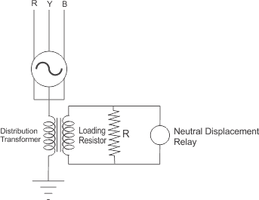

It is should be noted that, 100 % of the stator winding cannot be protected in resistance neutral earthing system.

How much percentage of stator winding would be protected against earth fault, depends upon the

The percentage biased differential relay comprises two restraint coils and one operating coil per phase. In the relay, the torque produced by operating coil tends to close the relay contacts for instantaneous tripping of [circuit breakers](https://www.electrical4u.com/electrical-circuit-breaker-operation-and-types-of-circuit-breaker/) but at the same time the torque produced by the restraint coils prevents to close the relay contacts as restraint coils torque is directed opposite of the operating coil torque. Hence during through fault the differential relay would not be operated because the setting of the relay is increased by restraint coils and also it prevents malfunctioning of relay due to spill current. But during internal fault in the winding of the stator, the torque produced by restraint coils is ineffective and the relay closes its contact when setting current flows through the operating coil. Differential current pickup setting/bias setting of the relay is adopted based on the maximum percentage of allowable mismatch adding some safety margin.  
The spill current level for the relay is to just operate it; is experienced as a percentage of the through fault current causing it. This percentage is defined as bias setting of the relay.

https://www.electrical4u.com/electrical/machine-equation/generator-equation/percentage-bias-22-3-15.gif

# Different Types of Electrical Transformer Protection Systems

# **Transformers are generally used to step up and step down the voltage level. Since transformer working under several voltage levels, it’s also require to have better protection in the transformers. There are the several type of transformer faults occurs and it can mainly divide into Internal faults and through faults. Internal fault of the transformers mainly happened due to the insulation breakdown of it. Insulation breakdown create short-circuit conditions inside the transformers. This will cause hazard situations so we need to special attention on this type of transformer fault.**

## ****Factors to Types of Electrical Transformer Protection****

**Transformer are use to protect on several kind of phenomena such as following.**

* **Open Circuit faults**
* **Short circuit faults**
* **Over loadings**
* **Surge lighting**

### ****Types of Electrical Transformer Protection Systems****

**Over current protection**

**Overcurrent protection of the transformers can done by using fuses , circuit breakers and relays. Protections systems are use as primary protection system of the transformers.**

**Differential Protection**

**Differential protection of the power transformer effect on the different current. This also should consider while apply a differential protection. The factors can also result in differential current in under balanced power conditions. Following are some of the situations which can occur.**

* **Magnetic in rush current**
* **Over excitation**
* **Current Transformer saturation**
* **Phase Displacement in Star Delta Winding**
* **Primary and secondary different voltage levels.**

**Differential Relays**

**Differential relays are used to reduce the mention effects of transformers. The percentage characteristic of the differential relays are vary in the rage of 15% to 60%. in Addition to that the modern microprocessor and numeric relays and harmonic restraints can apply in to it.**

### ****Transformer testing****

* **Open circuit tests**
* **Short circuit test**
* **Measurement of acoustic noise level**
* **Magnetic balance test.**
* **Measurement of zero phase sequence impedance test**
* **Measurement of harmonic of the no load current.**

### ****Buchholz Relay Protection****

**Buchholzs relay is one of the protection system which is really important in electrical power transformer. Normally there buchholz relay are gas actuated and its installed in oi. This protection equipment is used to immersed transformer for protection against all kind of faults.**

### **Transformer Lighting Protection**

**In transformers following methods are used to protection against the lightning such as.**

* **Earth Screen**
* **Lightning Arrestors**
* **Overhead Ground Wires**

**Following are the most commonly use transformer protection types which use in electrical transmission system.**

* **Earth fault on transformer windings**
* **Over fluctuating protection**
* **overload protection**
* **transformer feeder protection**
* **over current protection**
* **Directional protection of  parral transformer**
* **Biased differential protection of two and three winding transformers.**

### ****Transformer Protection****

### ****Power Transformer Faults****

[Transformers](https://www.electricaltechnology.org/2012/02/working-principle-of-transformer.html)are **vital equipment** in transmission and distribution network and so the **protection against internal and external faults** is a very important factor in the design of those networks.

**Transformers faults may occur:**

* In the dielectric (insulating) materials, namely in the oil.
* In the windings.
* In the core (less frequent).

#### ****Oil & Winding Insulation Faults****

**Transformer oils** are designed to provide **electrical insulation** under high electrical fields; any **significant reduction** in the **dielectric strength** may indicate that the oil is no longer capable of performing this vital function.

Some of the things that can result in a reduction in dielectric strength includepolar contaminants, such as water, oil degradation by products and cellulose paper breakdown*.* **Transformer faults may occur in the oil due to gas formation, ageing, contamination with air and lack of  level and pressure.**

In the event of a minor fault like damage to core bolt insulation, local overheating, etc., the arcing causes slow generation of gas in the oil. All faults in transformer core and windings result in the localized heating and breakdown of oil. When the fault is of very minor type such as hot joint, gas is released slowly and rises towards conservator.

A **major fault** where **severe arcing** takes place causes **rapid release of large volume of gas and oil vapor**. This **violent evolution of gas and oil vapor** does not have time to escape and **instead builds up pressure and bodily displaces the oil**, causing surge of oil to the conservator.

Faults may also occur in the **windings insulation material**, as a consequence of oil failure, ageing***,***overheating and insulation breakdown*.*

#### ****Core Faults****

If any portion of the core insulation **becomes defective** or the laminated structure of the core is **bridged by any conducting material** which can permit sufficient eddy current to flow, it will cause **serious overheating**. The insulated core bolts are used for tightening the core. If the insulation of these bolts **fails** and provides easy path for stray current, this will lead to **overheating**. **Mechanical impacts** during handling and transportation may apply to the transformer an **equivalent force above 3g (where g is the gravidity acceleration; g = 9.81 m/s2.)**, which can cause **distortion of the core**.

#### ****Windings Faults****

**Common windings faults are:**

* Faults between **primary and secondary windings** (short circuit) of the same phase.
* Short-circuit between the **turns of the winding**.

These faults usually are a result of **dielectric failure**, both between windings and between the turns of the same winding, due to **ageing of insulation material**, which may increase due to **overloads**.

It also must be considered that the windings are subject to **both radial and axial forces** related to the current and flux interactions. **Radial forces** in the inner winding (normally the LV winding) are in **compression** while the outer winding (normally the HV winding) forces are in **tension**.

Design of the windings and bracing must consider the **magnitude of these forces** and provide adequate strength to withstand them without **significant mechanical deformation** which could result in a **dielectric failure**.

Also**mechanical impacts**during handling and transportation*may apply*to the transformeran**equivalent force above 3g,** which can cause**distortion and/or displacement of the windings** and**decrease of the insulation of the windings.**

#### ****Overload Faults****

**The loading of transformer is decided by permissible temperature rise of windings and oil. Permissible oil temperature is 65 °C and hot spot temperature of the winding is 80 °C at rated load. As the load of the transformer does not remain steady and varies according to load curve, the loading of transformer becomes an important operating problem. The rated output of a power transformer is mentioned on its name plate with reference to specified temperature rise under specified test conditions. The output which can be obtained from a transformer without causing undue deterioration of the insulation may be either more or less than the name plate rating depending upon the operating conditions, such as ambient temperature, initial loading, cooling provision, life expectancy, etc.**

#### ****Overheating Faults****

**Overheating** in transformer may be caused by overloads above the **permissible over loads** specified by the manufacturers, according to IEC Standards (60354 for oil-filled transformers and 60905 for dry type transformers), and **external faults**, such as [short-circuits](https://www.electricaltechnology.org/2018/02/short-circuit-currents-and-symmetrical-components.html) on installations downstream. Most of these faults may be limited by proper [maintenance of a transformer](https://www.electricaltechnology.org/2018/03/power-transformers-maintenance.html).

**Overheating may cause a breakdown of the insulation of the windings.**

### ****Power Transformer Protection****

#### ****Built-On Protection****

#### **Transformers are provided with bullet on (internal protections) for dielectric failure (formation of gas), temperature, oil pressure, level, winding temperature and on load tap changer.**

**According to the construction type of transformers the following protections must be provided:**

Oil-filled transformers with conservator

* Buccholz relay for dielectric failure (**2 steps**: alarm and trip)
* Oil pressure and level switches (**2 steps**: alarm and trip)
* Thermostat for oil temperature (**2 steps**: alarm and trip)
* On-load tap changer protection (**2 steps**: alarm and trip)

**Buccholz relay** **has** **multiple methods to detect a failing transformer*.***

* On a **slow accumulation of gas**, due perhaps to slight overload, **gas produced by decomposition of insulating oil** accumulates in the top of the relay and **forces the oil level down**. A **float switch** in the relay is used to **initiate an alarm signal**. Depending on design, a **second float** may also serve to detect slow **oil leaks**.
* If an **arc forms**, **gas accumulation is rapid**, and oil **flows rapidly** into the conservator. This **flow of oil** **operates a switch** attached to a vane located in        the path of the moving oil.

Buchholz relays have a **test port** to allow the accumulated gas to be **withdrawn for testing**. **Flammable gas** found in the relay indicates **some internal fault** such as **overheating or arcing**, whereas **air** found in the relay may only indicate **low oil level or a leak**.

 For transformers equipped with cooling fans and pumps, the temperature devices are used to **automatically start and stop the forced cooling**. They are also equipped to **initiate an alarm and a trip** for very high transformer temperatures.

**Oil-filled sealed transformers**

* **Gas detection and oil level, pressure and temperature** in one single equipment (**DGPT 2** – Detection of Gas, Pressure and Temperature) with **2 levels** *(*alarm and trip*)*

**Dry type transformers**

* ***Temperature of windings****with****2 levels****(*alarm and trip*) –*resistance temperature detector***PT 100****(*platinum probe*) or****PTC****(“*Positive Temperature Coefficient*”), that is a****thermistor****(*semi conductive material sensitive to temperature*).*

**These protections have a direct action on the tripping coils of the circuit breakers**.

#### **Differential Protection** The **ideal way** of protecting any piece of power system equipment is to **compare the current entering that piece of equipment, with the current leaving it**.

Under normal healthy conditions the **two are equal**. If the two currents are not equal, then a **fault must exist**.

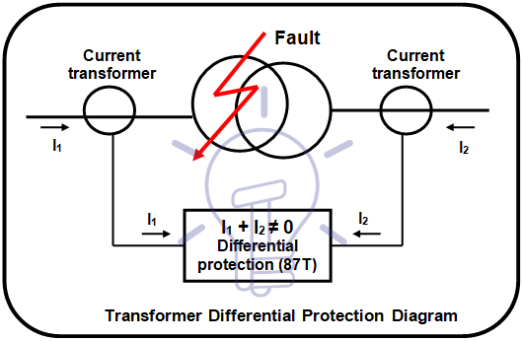

Figure 1 – Differential protection diagram

EHV and HV transformers and autotransformers for voltages above 49.5 kV and MV transformers with rated power above 3-4 MVA have usually as main protection a differential protection for winding faults – short-circuits between turns of a winding or between windings that correspond to phase-to-phase or three-phase type short-circuits.

If there is no [earthing / grounding connection](https://www.electricaltechnology.org/2015/05/earthing-and-electrical-grounding-types-of-earthing.html) at the transformer location point, this protection can also be used to protect against earth faults. If the earth fault current is limited by impedance, it is generally not possible to set the current threshold to a value less than the limiting current. This protection is connected to current transformers [CT (Current Transformers](https://www.electricaltechnology.org/2018/03/current-transformer-ct-types-applications.html)) at **both side of the transformer** (primary and secondary), as it was shown in Figure 1. The use of transformer differential protection poses some problems that must be taken into account:

***Problem*** *relating to the transformation ratio and the coupling method*

The primary and secondary currents have different amplitudes owing to the transformation ratio and different phases depending on the coupling method (delta-star transformer makes a phase displacement of 30°). Therefore, the current values measured must be readjusted so that the signals compared are equal during normal operation. This is done using matching auxiliary transformers whose role is to balance the amplitudes and phases.

When one side of the transformer is star-connected with an earthed neutral, the matching transformers on this side are delta-connected, so that the residual currents that would be detected upon occurrence of an earth fault outside the transformer are cleared. Figure shows an example of the connection of the differential protection, using matching auxiliary transformers.

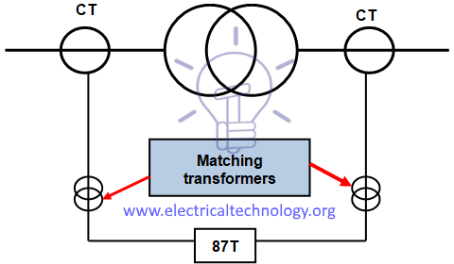

Figure – Transformer differential protection diagram

Nowadays, with electronic and micro processed protection units, this compensation is done through software.

Function of the protection is based on the transformation ratio “**n**” that can be expressed by the equation:

**n = (U1 / U2) = (I2 / I1)**

(U1: primary voltage; U2: secondary voltage; I1: primary current; I2: secondary current).

**The above relation is a consequence of the equation of the rated**[**power (**](https://www.electricaltechnology.org/2013/07/active-reactive-apparent-and-complex.html)**S) of the transformer:**

**S = √3 x U1 x I1 = √3 x U2 x I2**

***Problem relating to the transformer inrush current***

Transformer switching causes a very high transient current (from 8 to 15 In), which only flows through the primary winding and lasts several tenths of a second.

It is thus detected by the protection as a differential current and it lasts far longer than the protection operating time (30 ms). Detection based only on the difference between the transformer primary and secondary currents would cause the protection to be activated. Therefore, the protection must be able to distinguish between a differential current due to a fault and a differential inrush current.

Experience has shown that the inrush current wave contains at least 20% of second [harmonic components](https://www.electricaltechnology.org/2018/02/harmonics.html) (current at a frequency of 100 Hz), while this percentage is never higher than 5%upon occurrence of an overcurrent due to a fault inside the transformer.

The protection must therefore simply be locked when the percentage of second harmonic component in relation to the fundamental harmonic component (current at 50 Hz) is higher than 15%, i.e., “I2/ I1 > 15%”.

***Problem relating to the magnetizing current upon occurrence of an overvoltage of external origin***

Magnetizing current, or exciting current, is the current that flows through the primary winding of a power transformer when no loads are connected to the secondary winding; this current establishes the magnetic field in the core and furnishes energy for the no-load power losses in the core. It is responsible for “iron losses”.

The magnetizing current constitutes a difference between the transformer primary and secondary currents. It is therefore detected as a fault current by the differential protection even though it is not due to a fault. In normal operating conditions, this magnetizing current is very low and does not reach the protection operating threshold. However, when an overvoltage occurs outside the transformer, the magnetic material saturates(in general the transformers are dimensioned to be able to operate at saturation limit for the nominal supply voltage), and the magnetizing current value greatly increases. The protection operating threshold can therefore be reached. Experience has shown that the magnetizing current due to the magnetic saturation has a high rate of fifth harmonic components (current at a frequency of 250 Hz).

Transformer differential therefore requires fairly complex functions as it must be able to measure second and fifth harmonic current or, in order to avoid measuring fifth harmonic currents, it must be able to detect over voltages of external origin.

The characteristics of transformer differential protection are related to the transformer specifications:

* Transformation ratio
* Vector group
* Inrush current
* Permanent magnetizing current

#### ****Over-Current Protection**** MV transformers with rated power **up to 2.5 MVA** are usually only protected against over currents using over current relays.

* Three phase or phase-to-phase short circuit, instantaneous (ANSI/IEEE/IEC code 50).
* Three phase or phase-to-phase short circuit, time delayed (ANSI/IEEE/IEC code 51).
* Phase-to-earth short circuit, instantaneous (ANSI/IEEE/IEC code 50N).
* Phase-to-earth short circuit, time delayed (ANSI/IEEE/IEC code 51N).

This set of protections is used on HV and MV transformers with **rated power** above **3-4 MVA**as a “**back-up**” protection, in addition to the differential protection*.* In some installations and networks MV transformers with **rated power** up to **630 kVA** may be protected against over currents*by****fuses***associated to switch-disconnectors, as shown in Figure 2. In these situations the switch-disconnectors must have a **tripping coil** to allow the action of the built-on protections of transformers.

[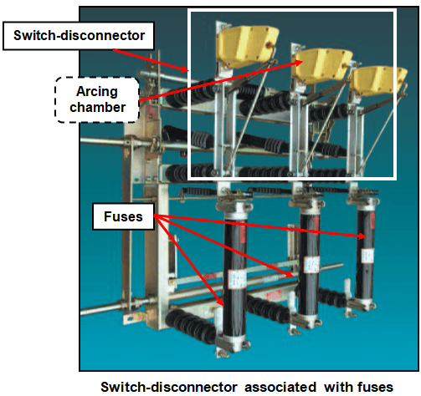](https://www.electricaltechnology.org/wp-content/uploads/2018/05/Switch-disconnector-associated-with-fuses.png)

Figure 2 – Switch-disconnector associated with fuses

Fuses must have a mechanical latch to indicate the fusion and to provoke three-pole opening of the switch-disconnector, to avoid the functioning of the installation only with two phases.

Manufacturers provide tables to choose the rated current of a fuse, taking into account the rated voltage and power, like the one shown in the Table 1, according to IEC standards.

Tables vary from manufacturer to manufacturer, according to the standards used, being recommended to use the table provided by the selected manufacturer.

#### ****Restricted Earth Fault Protection****

#### ****Restricted earth fault protection**** (ANSI/IEEE/IEC code 64G/64REF) is used as a complement or to replace differential protection for ****windings faults to earth****.

An external fault in the star side will result in current flowing in the line current transformer of the affected phase and at the same time a balancing current flows in the neutral current transformer, hence the resultant current in the relay is therefore zero.

So this protection will not be actuated for external earth fault. But during internal fault the neutral current transformer only carries the unbalance fault current and operation of the protection takes place.

This scheme of restricted earth fault protection is very sensitive for internal earth fault of electrical power transformer. The protection scheme is comparatively cheaper than differential protection scheme.

Restricted earth fault protection is provided in electrical power transformer for sensing internal earth fault of the transformer. In this scheme the CT secondary of each phase of electrical power transformer are connected together as shown in Figure 3.

[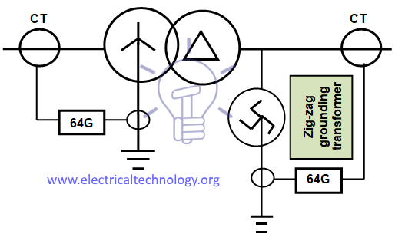](https://www.electricaltechnology.org/wp-content/uploads/2018/02/Transformer-restricted-earth-fault-protection-diagram.png)

Figure 3 – Diagram of restricted earth fault protection

Whenever there is an unbalancing in between three phases of the power transformer, a resultant unbalance current flow through the close path connected to the common terminals of the CT secondary.

An unbalance current will also flow through the neutral of power transformer and hence there will be a secondary current in Neutral CT because of this unbalance neutral current.

In restricted earth fault scheme the common terminals of phase CT are connected to the secondary of Neutral CT in such a manner that secondary unbalance current of phase CT and the secondary current of Neutral CT will oppose each other.

If these both currents are equal in amplitude there will not be any resultant current circulate through the said close path. The restricted earth fault protection is connected in this close path. Hence the relay will not response even there is an unbalancing in phase current of the power transformer.

#### ****Overload Protection****

#### The basic criterion for transformer loading is the **temperature of the hottest spot of the solid insulation** (hot-spot). It **must not exceed the prescribed value**, in order to avoid insulation faults, since loading capability of power transformers is limited mainly by **winding temperature**.

**The temperature of solid insulation is the main factor of transformer ageing.**

With temperature and time, the **cellulose insulation** undergoes a **depolymerization process**. As the cellulose chain gets shorter, the mechanical properties of paper such as tensile strength and elasticity **degrade**. Eventually the paper becomes brittle and is **not capable of withstanding short circuit forces** and even normal vibrations that are part of transformer life. This situation characterizes the **end of life of the solid insulation**. Since it is not reversible, it also defines the **transformer end of life**.

Transformer overloads can occur during contingency conditions that are the product of one, two, or various system elements being isolated from the power the system. They can also occur when transformers are already at **80%-90%** of their **full nameplate rating** and extra capacity is needed, especially during hot summers.

Traditionally, inverse-time overcurrent relays (an **inverse-time Curve** is characterized by the **inverse variation of current with the time**, as shown in Figure 4) for overload protection, but a **difficulty** is that transformers are usually outdoors where **ambient temperature affects their loadability**, and hence the optimum pickup settings of such relays.

[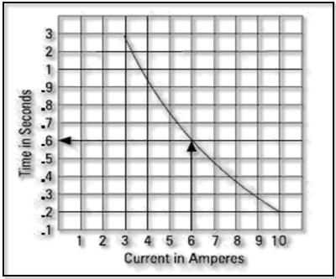](https://www.electricaltechnology.org/wp-content/uploads/2018/05/Inverse-time-characteristic-curve-in-overload-protection-of-transformer.png)

Figure 4 – Inverse-time characteristic curve

However, for liquid-immersed power transformers, the **temperature of the winding hot-spot** is the **important factor** in the long-term life of the transformer.

The **insulating oil temperature** is dependent on the winding temperature, and is used to **indicate the operating conditions of the transformer**. Many numerical transformer protection relays available today include protection functions that operate on **insulating oil temperatures**, calculated loss-of-life due to **high oil temperature**, and **predicted oil temperatures** **due to load**.

These types of functions **are not routinely applied**, but modern utility operating practices try to **maximize the utilization of power transformers**, which may increase the occurrence of over-temperature conditions and **transformer ageing**. Over-temperature conditions and accelerated aging are **adverse system events** that must be identified and protected against.

The most common function provided for **thermal protection** of power transformers is the **thermal overload** (ANSI/IEEE/IEC code 49) **function**.

The thermal capacity used is calculated according to a mathematical model which takes into account:

* Current **rms** values
* Ambient temperature
* Negative sequence current.

The protection gives a **trip order** when the heat rise **E**, calculated according to the measurement of an equivalent current **Ieq**, is **greater than the set point Es**.

The **protection tripping time** is set by the time constant **T**.

The thermal overload protection function may be used to protect equipment with **two operating rates**, for example transformers with **two ventilation modes**, with or without forced ventilation (**ONAN / ONAF**).

#### ****Lightning Protection****

**Lightning protection** **of power transformers** is achieved by **surge arresters** installed in the transformer tank, as shown in Figure 5.

[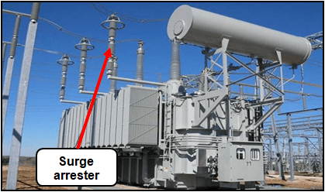](https://www.electricaltechnology.org/wp-content/uploads/2018/05/Lightning-protection-of-power-transformersby-surge-.png)

Figure 5 – Surge arrester

The most common surge arresters are [non-linear](https://www.electricaltechnology.org/2013/12/the-main-difference-between-linear-and-nonlinear-circuits.html)**metal oxide resistors** type in porcelain or silicone rubber housing, and are fitted in parallel with the object protected and connected to the earth grid.

**Resistance** of non-linear resistors is **in inverse proportion to the current**, that is to say that the **resistance is high for current service values** and **very low for high lightning discharge currents**.

#### ****Transformers Fire Protection System****

We have already discussed about it in detail in our previous post “[**Transformers Fire Protection System – Causes, Types & Requirements**](https://www.electricaltechnology.org/2018/02/transformers-fire-protection.html)“.

**Transformer fault types/protection methods**

|  |  |  |
| --- | --- | --- |
| **No.** | **Fault Type** | **Protection used** |
| 1. | Primary winding Phase-Phase fault | Differential; Overcurrent |
| 2. | Primary winding Phase-Earth fault | Differential; Overcurrent |
| 3. | Secondary winding Phase-Phase fault | Differential |
| 4. | Secondary winding Phase-Earth fault | Differential; Restricted Earth Fault (REF) |
| 5. | Interturn Fault | Differential; Buchholz |
| 6. | Core Fault | Differential; Buchholz |
| 7. | Oil tank Fault | Differential; Buchholz; Tank Earth |
| 8. | Over fluxing | Over fluxing |
| 9. | Overheating | Thermal |

# Busbar Protection

# When the fault occurs on the bus bars whole of the supply is interrupted, and all the healthy feeders are disconnected. The majority of the faults is single phase in nature, and these faults are temporary. The bus zone fault occurs because of various reasons likes failure of support insulators, failure of circuit breakers, foreign object accidentally falling across the bus bar, etc., For removing the bus fault, all the circuits connecting to the faulty section needs to be open.

The most commonly used schemes for bus zone protection are:

* Backup protection
* Differential Overcurrent Protection
* Circulating current protection
* Voltage Overvoltage Protection
* Frame leakage protection.

### Backup protection for Bus-Bars

This is the simple way of protecting the bus-bar from the fault. The fault occurs on the bus-bar because of the supplying system. So the backup protection is provided to the supply system. The figure below shows the simple arrangement for the protection of bus-bar. The bus A is protected by the distance protection of the bus B. If the fault occurs on A, then the B will operate. The operating times of the relay will be 0.4 seconds.

[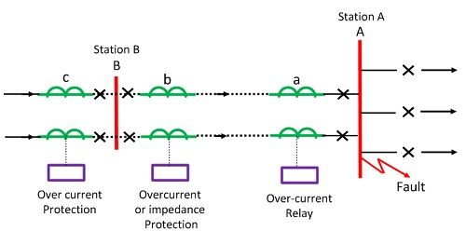](https://circuitglobe.com/wp-content/uploads/2016/07/backup-protection-for-bus-bar-compressor.jpg)

The bus-bar protection system has few disadvantages likes the protection system is slow. Such system is mainly used for the protection of the transmission lines. But as the protection system is very economical, thereby it is also used for the bus-bar protection.

This protective scheme is not used for small switchgear system. The backup protection system has many disadvantages likes delayed in action, disconnections of more circuits for two or more transmission line requires etc.

### Frame Leakage or Fault-Bus Protection

This method insulates the bus-supporting structure and its switchgear from the ground, interconnecting all the framework, circuit breakers tanks, etc. and provided a single ground tank connection through a CT that feeds an overcurrent relay. The overcurrent relay controls a multi-contact auxiliary relay that trips the breakers of all circuits connected to the bus.

In such type of protection, the only metal supporting structure or fault-bus is grounded through a CT, secondary of which is connected to an overcurrent relay. Under normal operating condition, the relay remains inoperative, but fault involving a connection between a conductor and the ground supporting structure will result in current flow to ground through the fault bus, causing the relay to operate. The operation of the relay will trip all the breakers connecting equipment to the bus.

### Differential over Current Protection

**Current Differential Protection**

The current differential protection scheme works on the principle of the circulating current which states that the current enters into the bus-bar is equal to the current leaving the bus-bar. The sum of the incoming and outgoing junction is equal to zero. If the sum of current is not equal to zero, then the fault occurs in the system. The differential protection scheme is used both for the protection of the phase-to-phase fault and for the ground fault.

Schematic diagram of bus differential protection relay is shown in the figure below. The current transformers are placed on both the incoming and the outgoing end of the bus-bar. The secondary terminals of the current transformer are parallel connected to each other.

[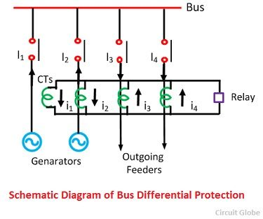](https://circuitglobe.com/wp-content/uploads/2016/07/schematic-diagram-of-bus-differential-protection-compressor.jpg)

The summation current of the current transformer flows through the operating coil of the relay. The current flows through the relay coils indicates the short circuit current present on the secondary of the CTs. Thus, the relay sends the signal to the circuit breakers to open the contacts.

The drawback of such types of the scheme is that the iron cored current transformer causes the fault operation of the relay at the time of the external fault.

**Voltage Differential Protection Relay**

In this scheme, the coreless CTs are used. The linear couplers are used for increases the number of turns on the secondary sides of the CTs. The secondary relays connected in series with the help of the pilot wires. The relay coil is also connected in series with the second terminal.

[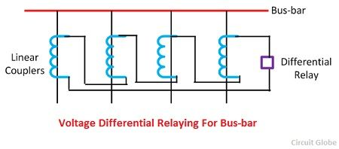](https://circuitglobe.com/wp-content/uploads/2016/07/voltage-differential-relay-compressor.jpg)

When the system is free from fault or external fault occurs on the system, the sum of secondary current of CTs becomes zero. On the occurrence of the internal fault, the fault current flows the differential relay. The relay becomes operative and gives command to the circuit breaker to open their contacts. Thus, protects the system from damage.

# Feeder Protection

**Definition**: Feeder protection is defined as the protection of the feeder from the fault so that the power grid continue supply the energy. The feeder injects the electrical energy from the substation to the load end. So it is essential to protect the feeder from the various type of fault. The main requirement of the feeder protection are;

1. During the short circuit, the circuit breaker nearest to the fault should open and all other circuit breakers remain in a closed position.
2. If the breaker nearest to the fault fails to open then, backup protection should be provided by the adjacent circuit breaker.
3. The relay operating time should be small to maintain the system stability without necessary tripping of a circuit.

## Time Graded Protection

This is a scheme in which the time setting of relays is so consecutive that in the event of a fault, the smallest possible part of the system is isolated. The applications of time graded are explained below.

### Protection of Radial Feeders

The main characteristic of a radial system is that power flow only in one direction, i.e. from the generator or the supply end to the load end. It has the drawback that continuity of supply cannot be controlled at the load end in the occurrence of a fault.

In a radial system when the number of feeders is connected in series as shown in the figure. It is desired that the smallest possible part of the system should be off. This is conveniently achieved by employing time graded protection. The over current system should be adjusted in such a way that the longer the relay from the generating station the lesser the time of operation.

[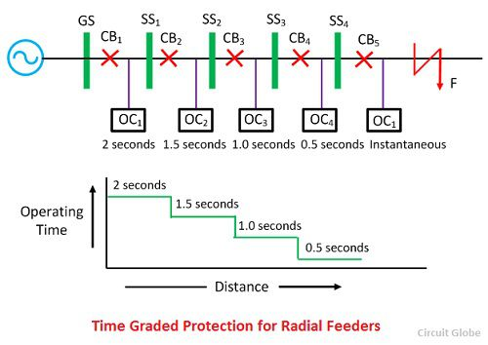](https://circuitglobe.com/wp-content/uploads/2016/10/time-graded-protection-for-radial-feeder.jpg)

When the fault occurs on the SS4, the relay OC5 should operate first and not any other i.e. the time require to operate the relay OC4 must be less than the time required for relay OC3 and so on. This shows that the time setting required for these relays must be properly graded. The minimum interval of time which can be allowed for the two adjacent circuit breaker depends on its own clearance time, plus a small time for the safety margin.

With normal circuit breaker in use minimum, the discriminating time between adjustment breaker should be about 0.4 seconds. The time settings for relay OC1, OC2, OC3, OC4, and OC5 will be 0.2 seconds, 1.5 seconds, 1.5 seconds, 1.0 seconds, 0.5 second and instantaneous respectively. Along with the grading system, it is also essential that the time of operation for the severe fault should be less. This can be done by using time limiting fuse in parallel with the trip coils.

### Protection of Parallel Feeders

The parallel connection of the supply is mainly used for the continuity of the supply and for sharing the load. When the fault occurs on the protective feeder, the protective device will select and isolate the defective feeder while the other instantly assume the increased load.

One of the simplest methods for the protection of the relay is the time graded overload relay with inverse time characteristic at the sending end and instantaneous reverse power or directional relays at the receiving end as shown in the figure below.

[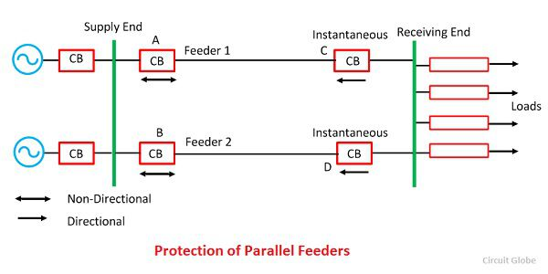](https://circuitglobe.com/wp-content/uploads/2016/10/protection-of-parallel-feeder.jpg)

When the heavy fault F occur on any one of the lines, then the power is fed into fault from the sending end as well as from the receiving end of the line. The direction of power flow will be reversed through the relay on D, which will be open.

The excess current is then restricted to B until its overload relay operates and trips the circuit breaker, thus completely isolating the faulty feeder and supplying power through the healthy feeder. This method is only satisfactory when the fault is heavy and reverse the power at D. Hence differential protection is also added along with the overloaded protection at both the end of the line.

### Protection of Ring Main System

The ring main is a system of interconnection between a series of the power station by a different route. In the main ring system, the direction of power can be changed at will, particularly when the interconnection is used.

The elementary diagram of such a system is shown in the figure below where G is the generating station, and A, B, C, and D are substation. At the generating station, the power flow only in one direction and hence no time lag overload relays is used. The time grade overload relay is placed at the end of the substation, and it will trip only when overload flows away from the substation which they protect.

[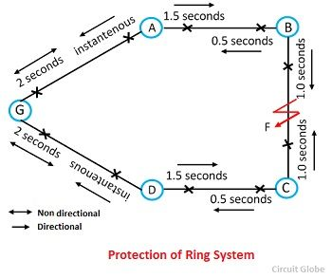](https://circuitglobe.com/wp-content/uploads/2016/10/protection-of-ring-main-system-compressor.jpg)

Going round the ring in the direction GABCD the relay on the further side of each station are set with decreasing time lags. At generating station 2 seconds at station A, B, C and 1.5 seconds, 1.0 second, 0.5 second and instantaneous respectively. Similarly going round the ring in the opposite direction the relay on the outgoing sides would be set as follows.

If the fault occurs at point F, the power F is fed into the fault through two paths ABF and DCF. The relay to operate is that between substation B and fault point F and substation C and fault point F. Thus the fault on any section will cause the relay on that section to operate, and the healthy section will be operating uninterruptedly.

**Transmission line protection**

Power transmission line protection systems is one of the most important system under electrical power system. Transmission system is a system which between the generation and the distribution centers. . There are two main power transmission system which use in electrical industry. Distance relays are use to protect transmission line and this are simple to apply . Advantage of the distance relays are they are high-speed operation. In here we are plan to discuss on several factors which affect on protecting high voltage transmission lines.

## Transmission Line systems

Electrical power transmission line systems can classified according to the type of current. Direct current and Alternative current are the two main types of current which utilized. Following are the transmission line classification according to the type of current supply.

**High Voltage Direct Current (HVDC) System** – HVDC Power transmission system are much used for the power transmission between very long distances.

#### ****High Voltage Alternating Current (HVAC) System****– HVAC power transmission system are much economical for shorter distance power transmission.

## Factors to Get Protected From

There are several factors which we need to consider while protection transmission lines. Following are those factors which got effect on the protection.

* Wind and Ice
* Contamination
* Vandalism
* External forces
* Equipment Failures
* System Disturbances
* Overloading of system
* Lightning

These factors play vital role on protect against of Transmission towers and lines of the electrical system.

## Transmission Line Protection Systems

If we consider about the protection of transmission line there are three protection types are used to protect these lines .

* Differential Protection
* Phase Comparison
* Over Current Protection
* Earth fault overcurrent protection (Use for protect from large residual current)
* Distance Protection
* Thermal overload protection (Use for underground power system)

We are plan to discuss more about this transmission line protection systems in our future articles separately.

## Transmission Line Protection Relays

Main purpose of the transmission protection relay are to identify the fault  of the location . This relays are also use to identify the type of the fault in transmission lines too. Transmission line protections are much based on relays. There are several relay system are use to protect transmission lines. Following are some of the protective relay types which use in transmission lines.

* + **Protective Relays**– Protective relays are function as to detect the fault and also to initiate the appropriate control signal such as the tripping signal.
  + **Regulating Relays** – Regulating relay is a device which manages the operation of the load of tap changer on the transformer.
  + **Reclosing  and Synchronizing Relays**this is a programmable relay whose the function is to initiate a sequence of actions leading to the automatic reclosing of the circuit breaker.
  + **Auxiliary Relays-**This relay which assist other relays by applying supplementary actions.

Normally protective relays are very important in transmission line protection. Hope that you have some basic understanding on the protections of the electrical power transmission lines . In future articles we are plan to discuss more about the other protections schemes of power transmission lines in future.

All the electrical power system works under zone protection and which can be divided in to several zones of protection. Each zone of protection, contains one or more components of a power system in addition to two circuit breakers. When a fault occurs within the boundary of a particular zone, then the protection system responsible for the protection of the zone acts to isolate (by tripping the Circuit Breakers) every equipment within that zone from the rest of the system. Some of the protecting zone has backup protection for their primary protection.

[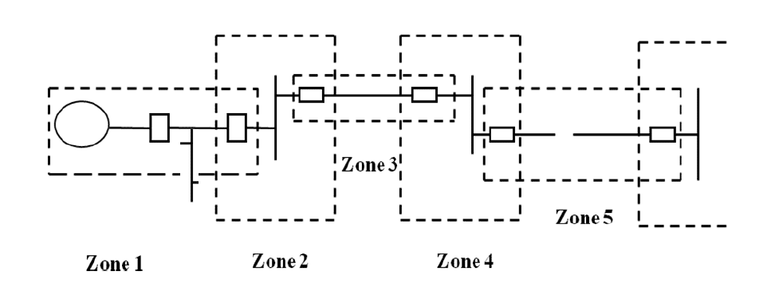](https://www.electrical4u.net/wp-content/uploads/2018/06/What-is-Zone.png)

The circuit Breakers are inserted between the component of the zone and the rest of the power system. Thus, the location of the circuit breaker helps to define the boundaries of the zones of protection.

Different neighboring zones of protection are made to overlap each other, which ensure that no part of the power system remains without protection. However, occurrence of the fault with in the overlapped region will initiate a tripping sequence of different circuit breakers so that the minimum necessary to disconnect the faulty element

### Overlapping Zone of Power System:

Overlapping Zones are having powerful advantage; If our power system does not contain overlapping in the protective zone means, then the failure occurs in the equipment will not lie in any one of the zones and hence no circuit breaker would be tripped. The fault occurs in the unprotected system will damage the equipment and hence disturb the continuity of the supply.

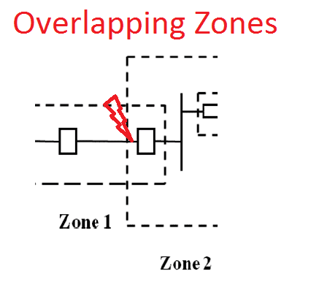

Consider the two protective zone 1 and Zone 2. Here zone 2 overlap the zone1.  If there is a fault occurs in the zone 2, the circuit breakers of zone 2 tripped along with the zone 1 circuit breaker. The relay of the zone 2 will also trip the circuit breaker of zone 1 for other faults in the zone 2 which occurs to the right of the circuit breaker. Hence the unnecessary tripping of the breaker can be tolerated only in the particular region.

**CTs and PTs and their applications in protection schemes**

# Current transformers are generally used to measure currents of high magnitude. These transformers step down the current to be measured, so that it can be measured with a normal range ammeter

**CTs and PTs and their applications in protection schemes**

 Current transformers are generally used to measure currents of high magnitude. These transformers step down the current to be measured, so that it can be measured with a normal range ammeter. A Current transformer has only one or very few number of primary turns. The primary winding may be just a conductor or a bus bar placed in a hollow core (as shown in the figure). The secondary winding has large number turns accurately wound for a specific turns ratio.

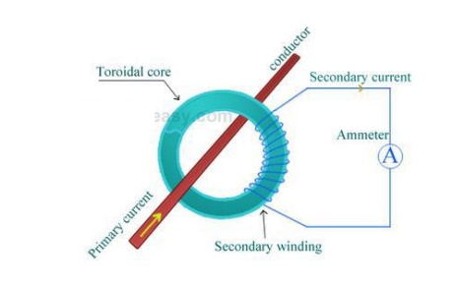

Thus the current transformer steps up (increases) the voltage while stepping down (lowering) the current. Now, the secondary current is measured with the help of an AC ammeter. The turns ratio of a transformer is NP / NS = IS / IP

* + UPS systems
  + Transfer switches
  + Motor-generator sets
  + Commercial sub-metering,
  + CT 's in one package for 3-phase metering
  + Accurate measuring for metering/WATT/VAR
  + Current sensing, recording, monitoring & control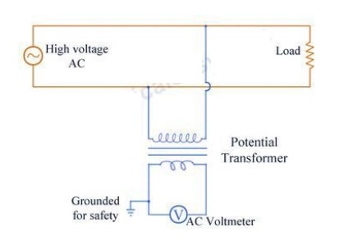
  + Control panels and drives
  + Standard CT used as measuring standard for comparison
  + Winding temperature indicator (WTI) for power transformers
  + Summation current transformers.

## Potential Transformer (PT)

Potential transformers are also known as voltage transformers and they are basically step down transformers with extremely accurate turns ratio. Potential transformers step down the voltage of high magnitude to a lower voltage which can be measured with standard measuring instrument. These transformers have large number of primary turns and smaller number of secondary turns. A potential transformer is typically expressed in primary to secondary voltage ratio. For example, a 600:120 PT would mean the voltage across secondary is 120 volts when primary voltage is 600 volts.

## Difference between C.T. and P.T.

|  |  |  |
| --- | --- | --- |
| SNo. | Current Transformer (C.T.) | Potential Transformer (P.T.) |
| 1 | Connected in series with power circuit. | Connected in Parallel with Power circuit. |
| 2 | Secondary is connected to Ammeter. | Secondary is connected to Voltmeter. |
| 3 | Secondary works almost in short circuited condition. | Secondary works almost in open circuited condition. |
| 4 | Primary current depends on power circuit current. | Primary current depends on secondary burden. |
| 5 | Primary current and excitation vary over wide range with change of power circuit current | Primary current and excitation variation are restricted to a small range. |
| 6 | One terminal of secondary is earthed to avoid the insulation break down. | One terminal of secondary can be earthed for Safety. |
| 7 | Secondary is never be open circuited. | Secondary can be used in open circuit condition |